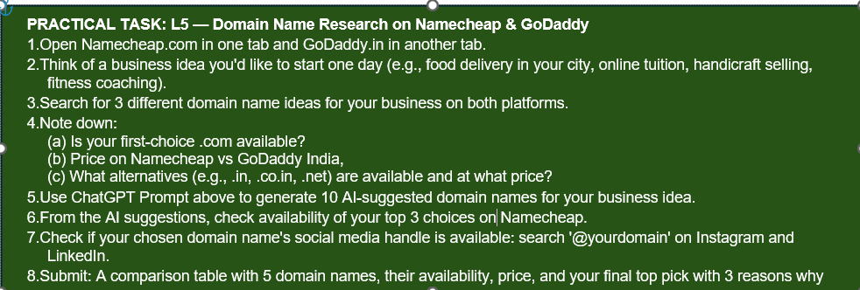Domain Name Research Report
- Business Idea: Interior Designing and Home Decor Services
- 10 AI-Suggested Domain Names
- AmaniInteriors.com
- DreamNestInteriors.com
- UrbanStyleInteriors.com
- LuxeHomeDesigns.com
- AmaniModernHomes.com
- AmaniDesignWorks.com
- AmaniCreativeSpaces.com
- AmaniHomeDecorStudio.com
- AmaniInteriorCraft.com
10.AmaniDesignNest.com
- Availability Check of Top 3 Choices on Namecheap
- AmaniInteriors.com
  - .com Availability: Not Available (Taken)
  - Alternative Available: AmaniInteriors.in
  - Other Alternatives: .org, .net, .to, .ai
- DreamNestInteriors.com
- .com Availability: Not Available (Registered)
- Alternatives Available: .org, .to, .ai
- LuxeHomeDesigns.com
    - .com Availability: Not Available (Taken)
    - Alternatives Available: .casa, .house, .org, .net, .in
- Social Media Handle Check
Instagram: @AmaniModernHomes – Checked
LinkedIn: AmaniModernHomes – Checked
- Final Top Pick
AmaniModernHomes.com
- Reasons for Choosing This Domain
- The .com version is available on both Namecheap and GoDaddy India.
- The name is easy to remember and clearly relates to homes and interior design.
- It has strong branding potential and looks professional for an interior design business.
- Conclusion
Most premium .com domain names were already registered. However, AmaniModernHomes.com was available at an affordable price and matched the business idea perfectly. Therefore, it was selected as the final domain name.

PRACTICAL TASK: L6 — Create InfinityFree Account and Install WordPress
9.Go to infinityfree.com and click 'Create Free Account'. Register with your email.
10.After logging in, click 'Create Account' → choose a free subdomain (e.g., yourbrand.epizy.com).
11.Once account is created, go to your Control Panel (it looks like cPanel).
12.Find 'Softaculous Apps Installer' and click on WordPress.
13.Install WordPress: Leave directory blank, set site name as '[Your Name] Digital Marketing Practice Site', create a unique admin username (NOT 'admin'), set a strong password.
14.After installation, log in to yourdomain.epizy.com/wp-admin and take a screenshot of your WordPress dashboard.
15.Navigate to: Appearance > Themes > Add New > Search 'Astra' > Install and Activate.
16.Go to Settings > General and change your Site Title and add a tagline.
17.BONUS: If you have budget (Rs. 99/month), sign up for Hostinger India instead and get a free domain!
18.Submit: Screenshot of WordPress dashboard + homepage of your new site.

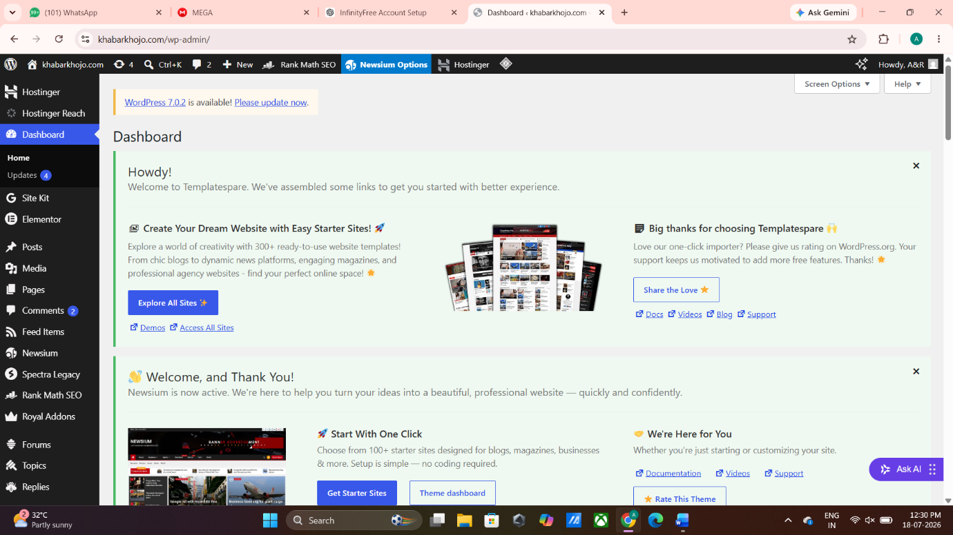

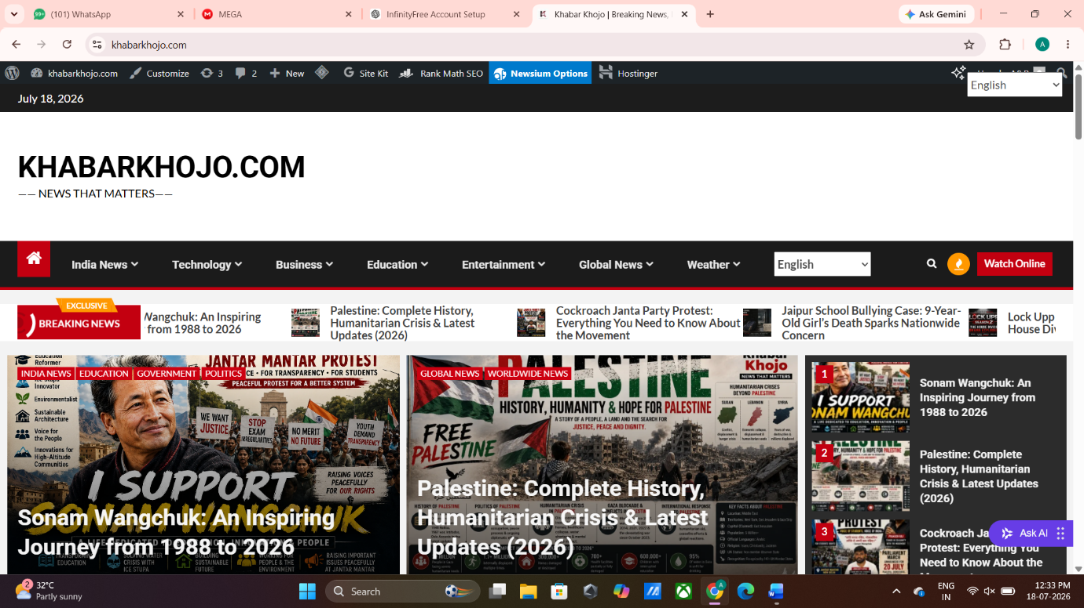
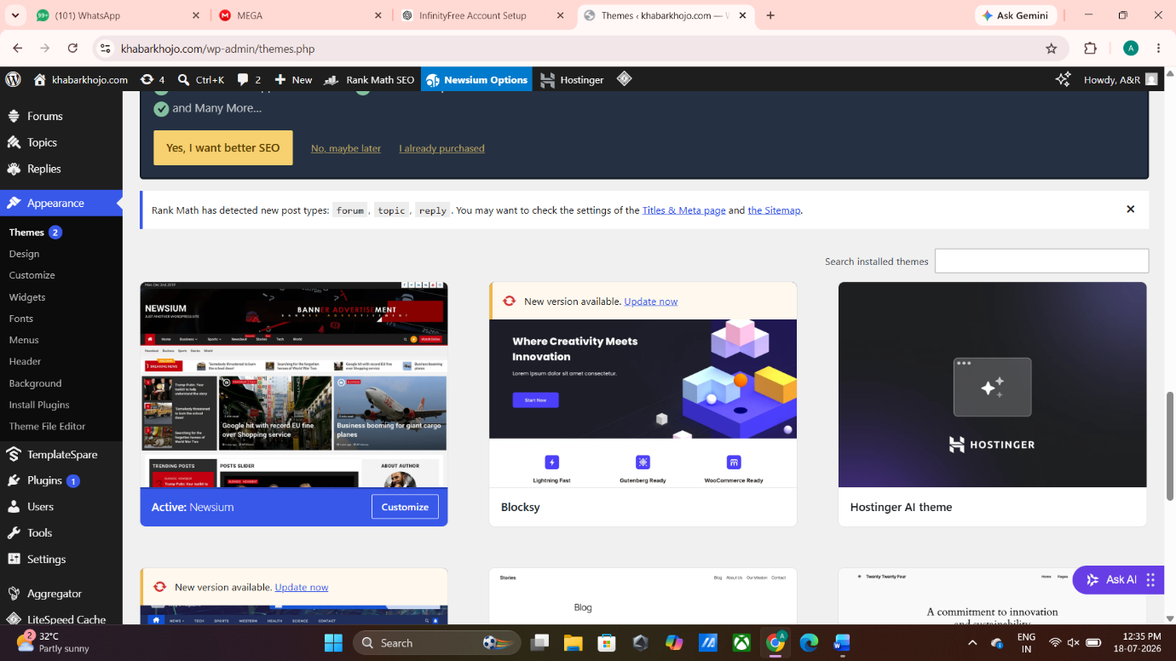
Current Theme :- Newsium

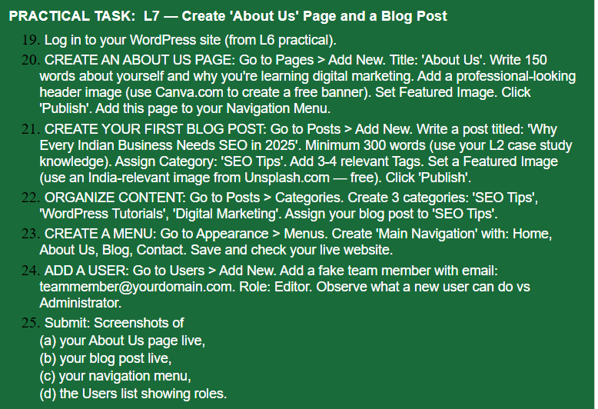
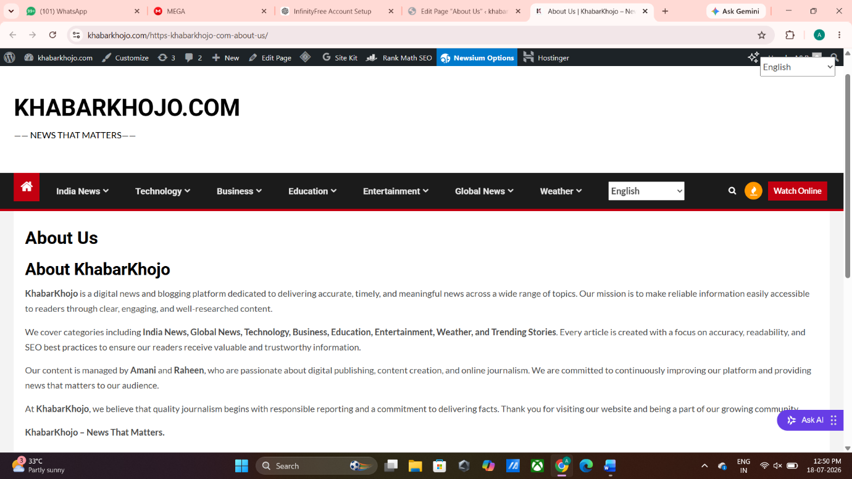

23.
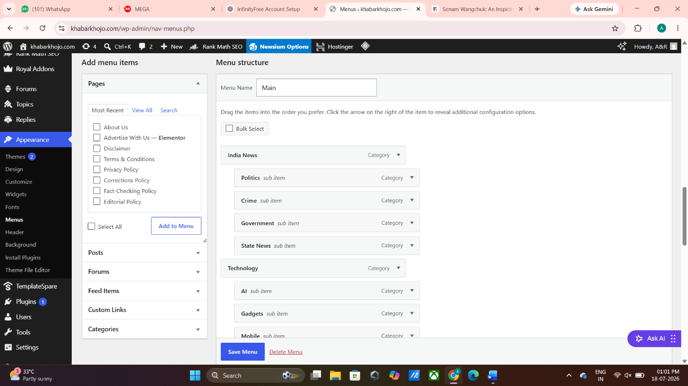
23.
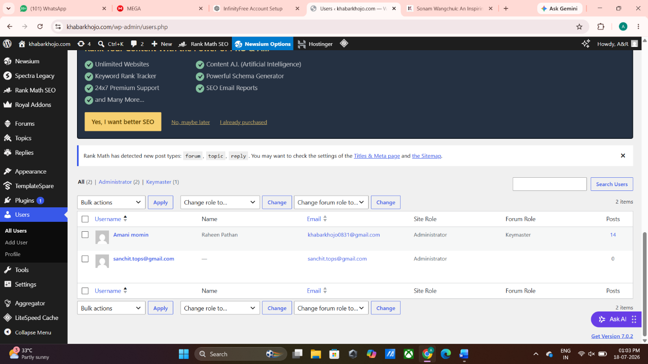

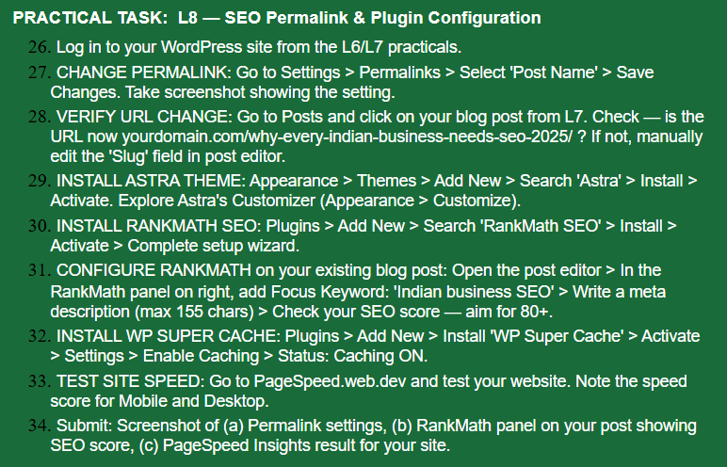
27.
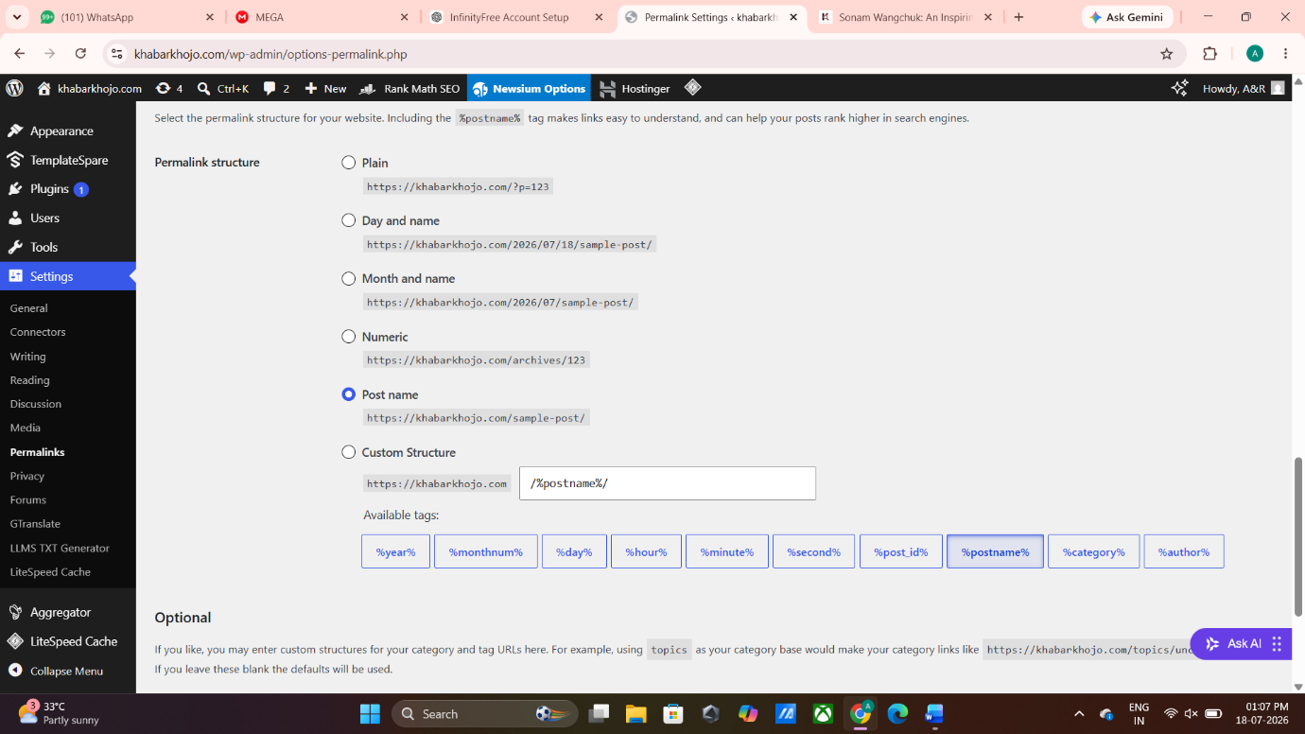

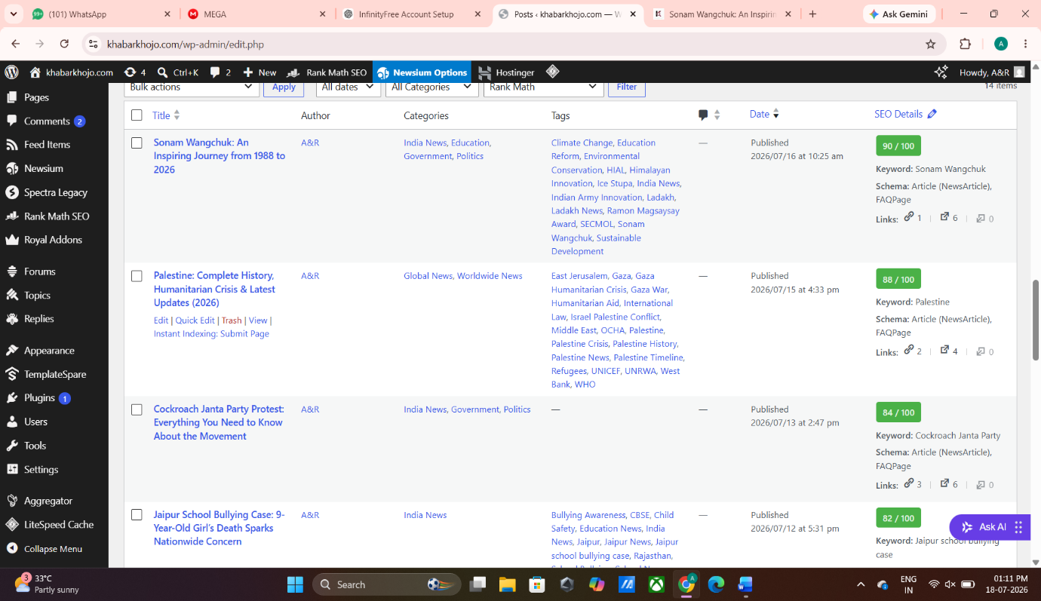
33.
